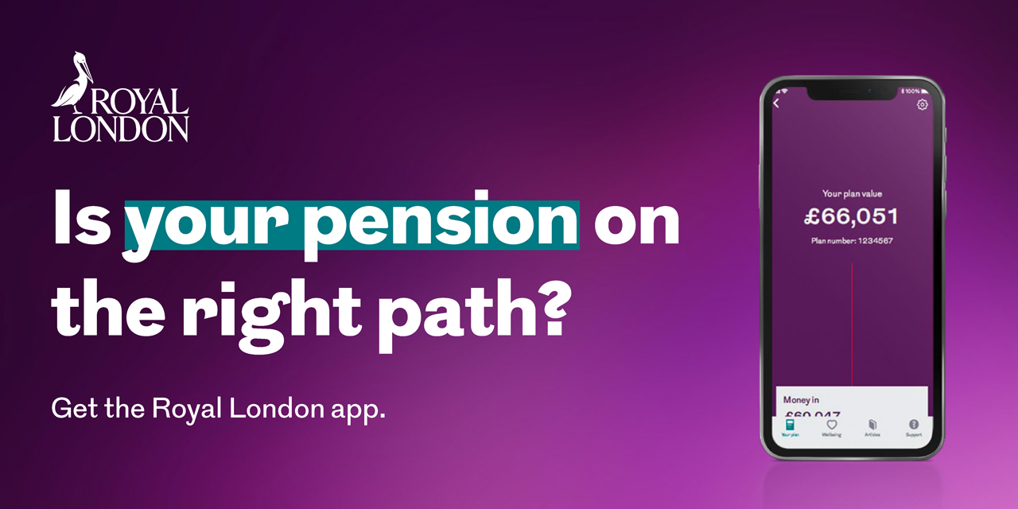
Dear [insert name of employee],
With the Royal London app you can:
- See your contributions.
- Stay up to date with your pension savings.
- See what your plan could be worth in the future.
- Add your beneficiaries.
- See your investments in more detail.
- Transfer other pension savings you have to your Royal London plan, if it’s right for you.
Remember, future pension values shown in the app are just estimates – your pension's value can change over time, both up and down.
Watch this short animation to find out more about the app.
Getting started
Download the Royal London app for free on the App Store or Google Play.
Royal London regularly updates their app's features to serve you better. So, keep checking in to make sure you don’t miss out.
Royal London’s pension plan, with its range of investment options, is here to help you save for retirement. It's a long-term commitment, so make sure to review your pension plan regularly to keep it in line with your retirement dreams.
Yours sincerely,
[Name Surname]
[Title]
[name.surname@email.com]
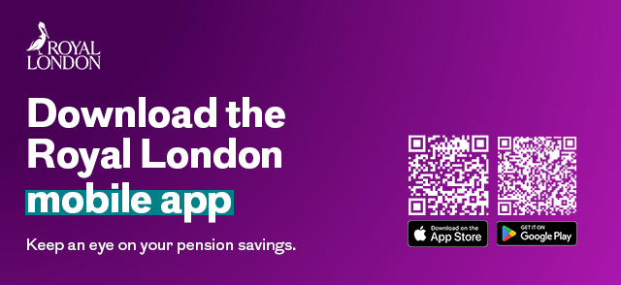

Apple and the Apple logo are trademarks of Apple Inc., registered in the U.S. and other countries. App Store is a service mark of Apple Inc. Google Play and the Google Play logo are trademarks of Google LLC.
March 2025 | E P EM 0978/1

