

Hello [insert name of employee],
Did you know that your Royal London workplace pension gives you free access to a financial wellbeing service?
This service could help you take control of your finances, from budgeting and saving for the future to managing debt and planning for retirement.

What you’ll get:
- Personalised dashboard that helps you understand your financial health and gives you the tools to improve it.
- Personalised financial guidance on a range of topics.
- Interactive tools: including a financial health check, a benefits calculator, and a retirement planning tool.

How to get started:
- Watch an introductory video
- Access the financial wellbeing service
- Complete your financial health check

You’ll need to be registered for Royal London’s online service to use these features. If you’re not registered, you’ll be prompted to do so with your plan number.

Yours sincerely,
[Name Surname]
[Title]
[name.surname@email.com]
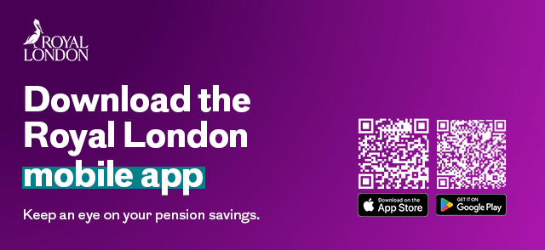Apple and the Apple logo are trademarks of Apple Inc., registered in the U.S. and other countries. App Store is a service mark of Apple Inc. Google Play and the Google Play logo are trademarks of Google LLC.
December 2025 | EP EM 1937

