

Hello [insert name of employee],
When you save into your workplace pension, you get tax relief from the government, which can help boost your pension savings.
There are limits to how much you can save into your pension plan/s each year without being subject to a tax charge, these are called pension allowances.
More about pension allowances
These allowances are for the 2026/27 tax year. Tax rules can change, and how they affect you depends on your circumstances.
The annual limit and the annual allowance on pension contributions
You can contribute up to 100% of your gross UK earnings (or £3,600, whichever is higher) and receive tax relief. This is called your annual limit.
The annual allowance limits total pension contributions each tax year (from you, your employer, and others) before a tax charge applies. It’s currently £60,000.
You can ‘carry forward’ unused annual allowance from the previous three tax years. If you still have allowance left, you could make a lump sum pension contribution.
Remember that the value of investments can go down as well as up, and you may not get back the full amount you invest.
Help staying on track
Keep an eye on the contributions into your plan using Royal London’s mobile app. Available through your mobile app store or by using the QR code below.
Other allowances that could affect you
Money purchase annual allowance (MPAA) If you've accessed your pension savings flexibly, your annual allowance may be limited to £10,000.
Tapered annual allowance If your yearly income is £200,000 or higher, your annual allowance may be reduced to as low as £10,000.
Lump sum allowance (LSA) The LSA is the maximum amount of pension savings that you can receive tax-free across your pensions. Usually, 25% of your pension savings can be taken tax-free, capped at £268,275.
Lump sum and death benefit allowance (LSDBA) Is the lifetime limit of all tax-free payouts, including lump sum death and serious ill-health benefits you receive before it’s taxed. It’s currently £1,073,100.
Are you affected by these limits?
If think you might need advice, you should speak to a financial adviser. If you don’t already have a financial adviser, you can find one in your area by visiting royallondon.com/find-a-financial-adviser
Advisers may charge for their services, though they should agree any fees with you upfront.
Yours sincerely,
[Name Surname]
[Title]

[name.surname@email.com]
Want to know more about your pension? [Use for relief at source GPP schemes]
Explore your employee hub to learn how your pension works, where your savings are invested and how to make the most of your plan.
If you’re not already paying into your workplace pension plan, contact [insert contact details] for more information.
Want to know more about your pension? [Use for Salary Exchange GPP schemes]
Explore your employee hub to learn how your pension works, where your savings are invested and how to make the most of your plan.
If you’re not already paying into your workplace pension plan, contact [insert contact details] for more information.

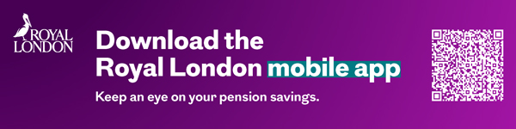
April 2026 | E P EM 0654/4

