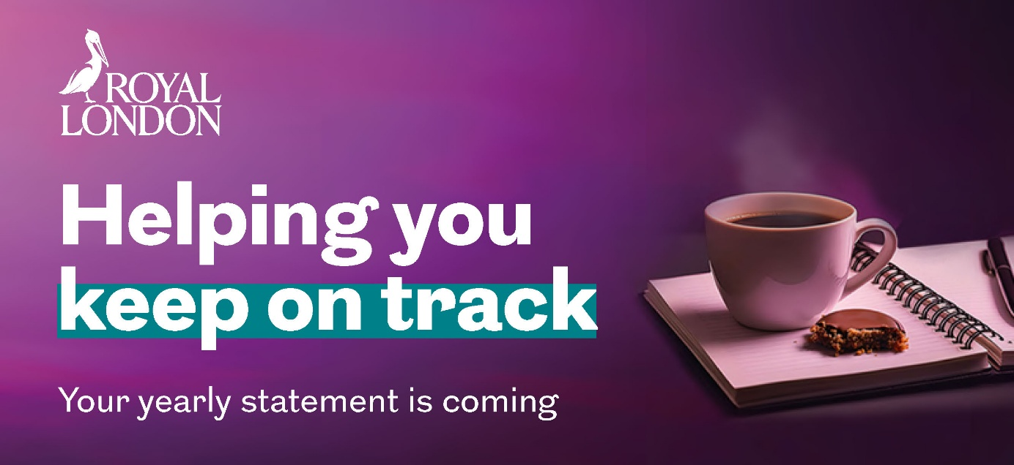

Dear [insert name of employee],
You’ll soon receive your yearly pension statement from Royal London. Your statement will show;
- the current value of your savings,
- contributions paid into your plan,
- investment performance,
- any ProfitShare your plan qualifies for and
- the charges you’ve paid.

Your video pension statement
You can now see how your pension savings are performing with a video pension statement sent straight to your inbox.
Your personalised video brings your pension savings to life, showing how they’ve grown, how they’re performing, and how they’re helping you plan for the retirement you want. It matches your printed yearly statement in a quick, clear, and easy-to-digest video format to help you stay informed about your pension progress
What you need to do next
You’ll receive a video pension statement if you’ve provided Royal London with your email address. You’ll be asked to log in to online service to view your video, if you’ve not registered you can sign up using the mobile app.
If you haven’t provided an email address, update your email address today to ensure you receive your video pension statement by using our online form.
Take control, stay informed and on track for your financial future.
Yours sincerely,
[Name Surname]
[Title]
[name.surname@email.com]
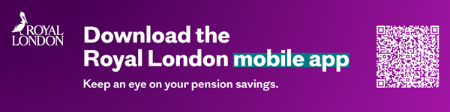
November 2025 | EPEM1667/1

