



Dear [insert name of employee],
Have you ever wondered what to do with your workplace pensions from previous jobs?
If you’ve had more than one job in your lifetime, you might have a few pension pots with different providers. You might want to consider combining them.
Why combine your pension savings?
Combining your pensions with Royal London could make it easier to keep track of them and help you to feel more in control of your financial future. If you choose to combine with Royal London and invest in their Governed Range, you'll have investment experts actively managing your pension.

- Simplicity
You may have less paperwork to deal with if your pension savings are together in one place.

- ProfitShare
Royal London is a mutual, which means they’re customer owned so you might get a share of their profits if they do well.

- Plan charges
Different plans have different charges. Moving to a plan with lower charges could save you money and help your plan grow.

Things to consider before combining your pensions

Before you continue, make sure you understand if you can transfer your pension and if a transfer is right for you. You should check and compare the charges you're paying on each plan.

You might want to keep your pensions separate if you have different goals for each one. Your other pensions may also have valuable features that can’t be replaced once you transfer your pension.

Making your decision

It's important to understand all the risks and benefits before making a decision. There's no guarantee that combining your pensions will give you a higher income or bigger pension pot. Your pension is invested, its value can go down as well as up and you could get back less than invested.

Combining your pension savings
It’s simple to transfer any existing pension savings into your Royal London plan.
If you decide combining your pensions is right for you, you can visit their pensions transfer hub to find out more about the benefits of bringing all of your pension savings together, things you need to consider and how to start your transfer if you decide to proceed.

Yours sincerely,
[Name Surname]
[Title]

[name.surname@email.com]

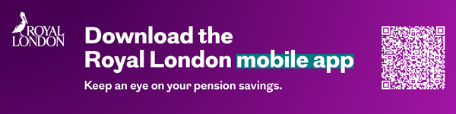

January 2026 | E P EM 1569/4

