
Dear [insert name of employee],
Our workplace pension with Royal London is set up to help you save for your retirement.
Discover more
In this short video, our Employee Engagement Consultant, Georgia Natty, answers some common questions you might have. This can help you take control of your future pension savings.
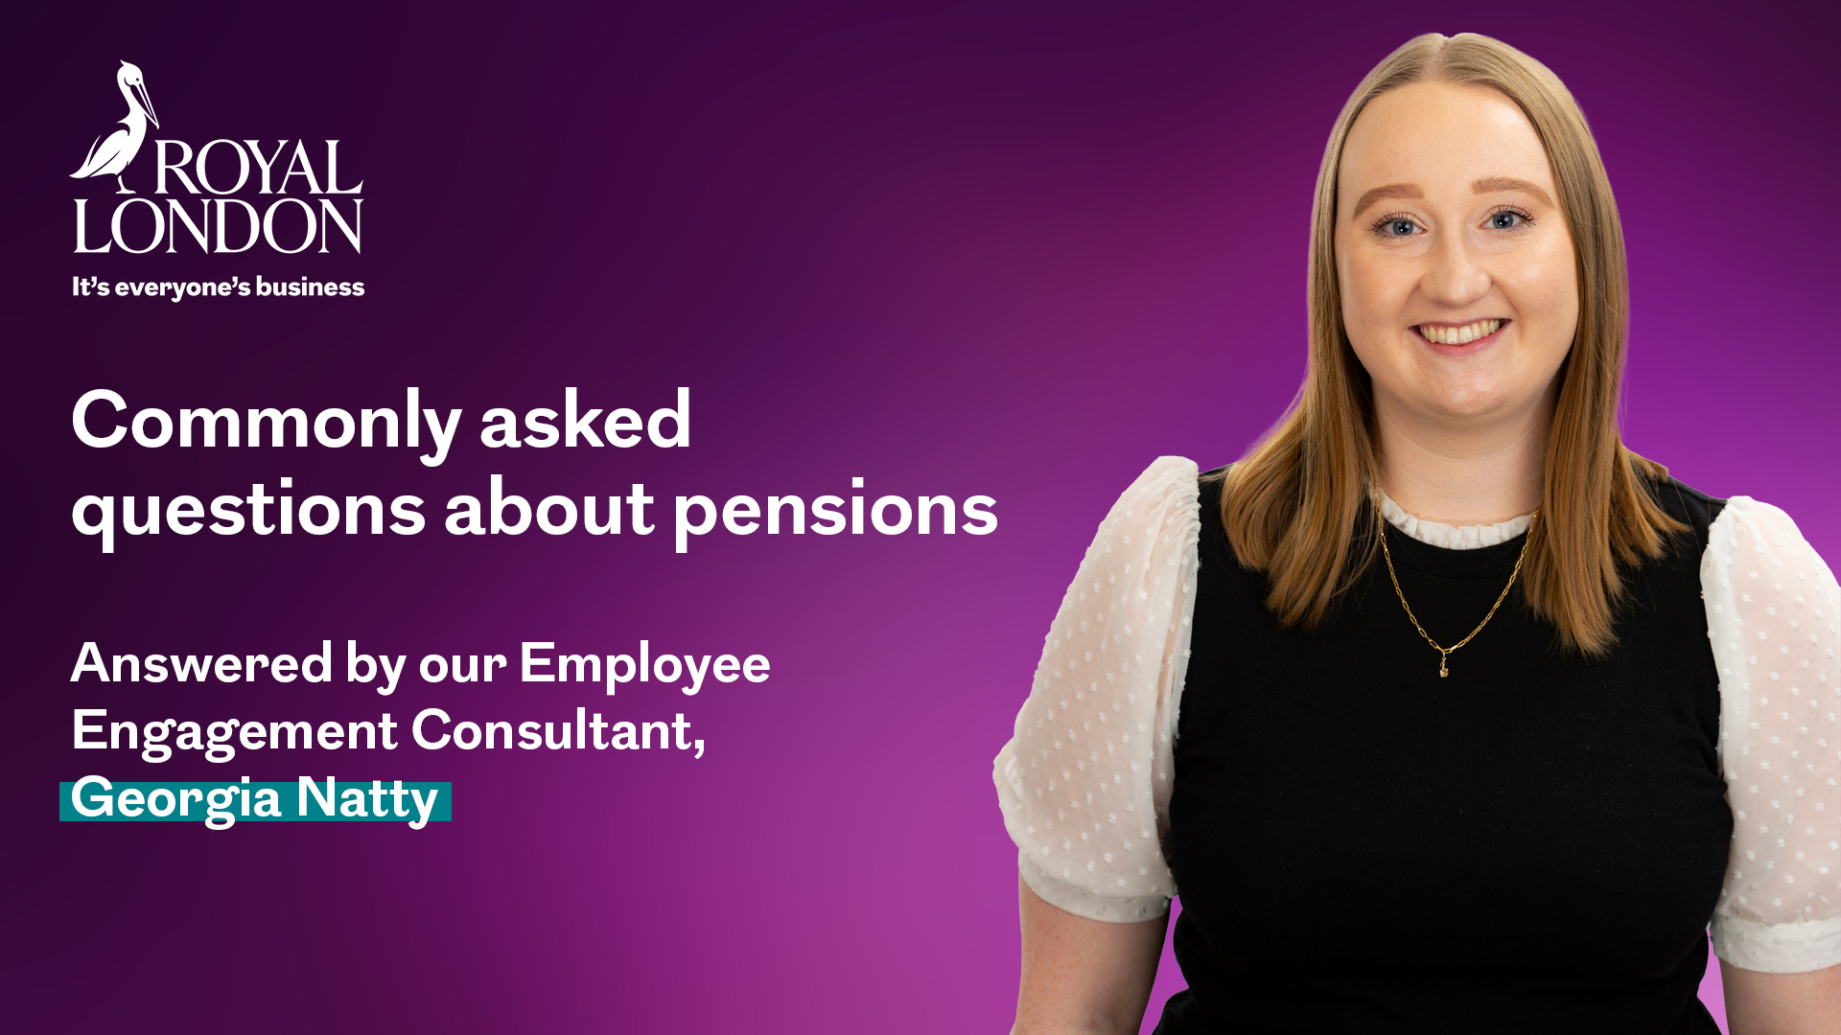

Yours sincerely,
[Name Surname]
[Title]
[name.surname@email.com]


March 2026 | E P EM 1193/3

