
Dear [insert name of employee],
Your pension is probably one of your most valuable assets.
So, while it's not easy to think about, it's important you decide who should receive your pension savings in the event of your passing. Nominating beneficiaries can help make sure your wishes are followed and avoid any unnecessary delays in distributing your pension savings.
Nominate your beneficiaries today
Nominating your beneficiaries is quick and easy, giving you peace of mind that Royal London will take your wishes into account.

You can do this in any of the following ways:

- Through the Royal London mobile app. Simply click on ‘see your plan’ then select 'Your beneficiaries'.
- By downloading and printing this paper form and sending it in the post.
- With Royal London’s secure online form.

If you don’t already have the Royal London mobile app you can download it from your app store the Royal Londons’ website or by scanning the QR code below.
Yours sincerely,
[Name Surname]
[Title]
[name.surname@email.com]
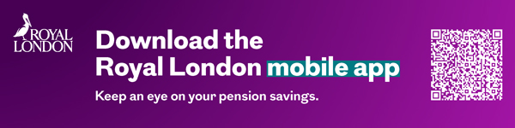
January 2026 | E P EM 0664/2

